[Intro]

**G**

[Verse 1]

**G**

I wanna sweep you off your feet tonight

**D**

I wanna love you and hold you tight

**Em**

Spin you around on some old dance floor

**C** **Cm**

Act like we never met before for fun,

[Chorus]

**G**

‘Cause you’re the one I want, you’re the one I need

**D**

Baby, if I was a king, ah, you would be my queen

**Em**

You’re the rock in my roll

**C**

You’re good for my soul, it’s true

**Cm** **G** **D** **C**

I’m head over boots for you

[Verse 2]

**G**

The way you sparkle like a diamond ring

**D**

Maybe one day we can make it a thing

**Em**

Test time and grow old together

**C** **Cm**

Rock in our chairs and talk about the weather, yeah

**G**

So, bring it on in for that angel kiss

**D** **Cm**

Put that feel good on my lips,

[Chorus]

**G**

‘Cause you’re the one I want, you’re the one I need

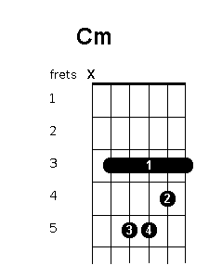 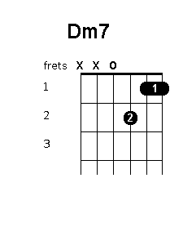

**D**

Baby, if I was a king, ah, you would be my queen

**Em**

You’re the rock in my roll

**C**

You’re good for my soul, it’s true

**Cm** **G**

I’m head over boots for you

[Bridge]

**G**

Yeah, I’m here to pick you up

**Dm7** **C** **Cm**

And I hope I don’t let you down, no,

[Chorus]

**G**

‘cause you’re the one I want, you’re the one I need

**D**

Baby, if I was a king, ah, you would be my queen

**Em**

You’re the rock in my roll

**C**

You’re good for my soul, it’s true

**Cm** **G**

I’m head over boots for

**G**

You’re the one I want, you’re the one I need

**D**

Baby, if I was a king, ah, you would be my queen

**Em**

You’re the rock in my roll

**C**

You’re good for my soul, it’s true

**Cm** **G** **D** **Em** **C** **Cm**

I’m head over boots for you

**G**

I wanna sweep you off your feet tonight

**D**

I wanna love you and hold you tight

**C** **Em** **Am** **Cm** **G**

Spin you around on some old dance floor....

 