Intro 24 BPM – very slow

[Verse 1]

|G D/F#|Em7

Don't you know

|G D/F#|Em7

that we're out of touch

|G D/F#|Em7

Yeah, we fight too much

|G D/F#|Em7

How'd we ever get so messed up?

|G D/F# |Em7

Every night,

|G D/F#|Em7

we say the craziest things

|G D/F#|Em7

You know our words they once had wings.

|G

Now it's all covered up

|D/F#

In double-talk and lies

|Em7

There's a stranger looking back

|C

When I look in your eyes

[Increase tempo to 146 BPM]

|G |Em7 |G |Em7

[Verse 1 Repeated]

|G |Em7

Well Don't you know

|G |Em7

that we're out of touch

|G |Em7

Yeah, we fight too much

|G | Em7

How'd we ever get so messed up?

|G |Em7

Every night

|G |Em7

we say the craziest things

|G |Em7

You know our words they once had wings.

|G

Now it's all covered up

|D/F#

In double-talk and lies

|Em7

There's a stranger looking back

|C |

When I look in your eyes

[Chorus]

|D |Em |C |G

I just want to find a heart like mine

|D |Em |C |G

I just want to find a heart like mine

|Am |Em |C |Dsus4 | |

A heart like mine, a heart like mine

|G |Em7 |G |

[Verse 2]

|Em7 |G |Em7 |G |

And You call me a fool, 'cause I still feel the same

|Em7 |G |

You say that your love has changed

|Em7 |G |

Ah! Here we go again

|Em7 |G |Em7 |G |

yeah Close your eyes tell me what do you see

|Em7 |G

Do you still remember me?

|Em7 |G |

Like some Mexican diplomat

|D/F#

After the fact

|Em7

Air-brushed from history

|C |C |

Swept under the mat.

[Chorus]

|D |Em |C |G

I just want to find a heart like mine

|D |Em |C |G

I just want to find a heart like mine

|Am |Em |C |Dsus4 | |

A heart like mine, a heart like mine

|G |Em7 |G |Em7 |G |Em7 |G |Em7 |Am |Em |C |Dsus4 |

|G |

And as I walk out the door

|Em7 |G |

I step into a dream.

|Em7 |G |Em7

The world's quiet and I feel free,

|G |

But things are never what they seem

|Em7 |G |

But then I hear you call

|Em7 |G |Em7

And warn myself - now don't go back

|G |Em7

But slow motion attacks

|G |

Like some Mexican diplomat

|D/F#

After the fact

|Em7

Air-brushed from history

|C |C |

Swept under the mat.

[Chorus]

|D |Em |C |G

I just want to find a heart like mine

|D |Em |C |G

I just want to find a heart like mine

|Am |Em |C |Dsus4 | |

A heart like mine, a heart like mine

|G |Em7 |G |Em7 |G |Em7 |G |Em7 |D/F# |Em7 |C |

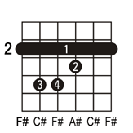 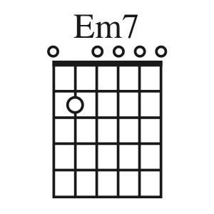

F#