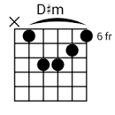 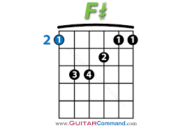 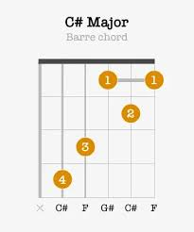

[Intro]

D#m B F# C#

[Verse]

D#m B F#

Jack and Jill went up the hill to get a little high

C#  
Sat and talked for hours how they wanted more from life  
 D#m F#

She promised him forever as she looked him in the eyes  
 C#  
Little did Jack know that every word of it was lies

[Chorus]

D#m B

And it all came tumbling down When he found out she's sleeping around  
 F# C#

Oh, where does it leave those promises now?  
 D#m B

King of the hill but she's broken his crown And his heart sinks, his head's in the clouds  
 F# C#

She left him so low with her goodbye

D#m B F# C#

Now Jack's just getting high… Oh, now Jack's just getting high and high and high

D#m B F# C#

Now Jack's just getting high .. Oh, now, yeah, Jack's just getting high and high and high

[Verse]

D#m B F#

Sometimes Jill goes up the hill to think back on those times  
 C#  
Looks out on the world, wonders what Jack made of his life  
 D#m F#

She promised him forever when she looked him in the eyes  
 C#  
She knew then that every single word of it was lies

[Chorus]

D#m B

And it all came tumbling down When she found out he's moved out of town  
 F# C# D#m

What goes 'round always comes back around If only she hadn't broken his crown  
 B F#

Maybe Jack would be with her now, She wasted all her time with other guys

D#m

While Jack was getting high

B F# C# D#m  
Oh, now Jack's just getting high and high and high, Now Jack's just getting high  
 B F# C# D#m  
Oh, now, yeah, Jack's just getting high and high and high, Now Jack's just getting high

B F# C# D#m  
Oh, now Jack's just getting high and high and high, Now Jack's just getting high  
 B F# C# D#m  
Oh, now, yeah, Jack's just getting high and high and high, Now Jack's just getting high

B F# C# N/C

Now Jack's just getting high