CHORDS
A F#m D E Bm E7
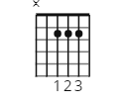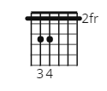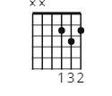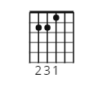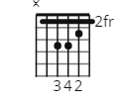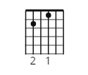
[Intro]
| A | % | F#m | % |
| A | % | F#m | % |

[Chorus]
D E A
No I would not give you false hope
D E A
On this strange and mournful day
D E A F#m
But the mother and child reunion
Bm A E
Is only a motion away

[Verse 1]
F#m
Oh oh, little darling of mine
E
I can't for the life of me
F#m
Remember a sadder day
E
I know they say let it be
F#m
But it just don't work out that way
D
And the course of a lifetime runs
E E7
Over and over again

[Chorus]
D E A
No I would not give you false hope
D E A
On this strange and mournful day
D E A F#m
But the mother and child reunion
Bm A E
Is only a motion away

[Verse 2]
F#m
Oh oh, little darling of mine
E
I just can't believe it’s so
F#m
Though it seems strange to say
E
I never been laid so low
F#m
In such a mysterious way
D
And the course of a lifetime runs
E E7
Over and over again

[Chorus]
D E A
But I would not give you false hope
D E A
On this strange and mournful day
D E A F#m
When the mother and child reunion
Bm A E
Is only a motion away

[Outro]
D E A
Oh the mother and child reunion
D E A
Is only a motion away
D E A F#m
Oh the mother and child reunion
Bm A E
Is only a moment away, hey, hey, hey

D E A
Oh the mother and child reunion
D E A
Is only a motion away
D E A F#m
Oh the mother and child reunion
Bm A E
Is only a moment away, oh oh

D E A
Oh the mother and child reunion
D E A
Is only a motion away
D E A F#m
Oh the mother and child reunion
Bm A E
Is only a moment away, away, away, away

(repeat and fade)

